National University of Technology

Machine learning Lab



Group | Muhammad Abdullah Khan 18  Husnain Haider 04  Alishba Shahzad 22  Memoona Rashid
Instructor | Sir Umer Aftab
Date | 31 March 2026

Post Lab Task

Without Jax:

Base Code:

import pandas as pd
import numpy as np
import time
from sklearn.preprocessing import StandardScaler
from sklearn.metrics import accuracy_score

# -------------------------
# Load your datasets
# -------------------------
train_data = pd.read_csv("train.csv")
test_data = pd.read_csv("test.csv")

# -------------------------
# Preprocessing
# -------------------------
features = ['Pclass', 'Sex', 'Age', 'SibSp', 'Parch', 'Fare']

# Fill missing values
train_data['Age'].fillna(train_data['Age'].mean(), inplace=True)
test_data['Age'].fillna(train_data['Age'].mean(), inplace=True)

# Encode categorical
train_data['Sex'] = train_data['Sex'].map({'male': 0, 'female': 1})
test_data['Sex'] = test_data['Sex'].map({'male': 0, 'female': 1})

# Drop rows with missing values
train_data = train_data.dropna(subset=features + ['Survived'])

# Extract X and y
X_train = train_data[features].values
y_train = train_data['Survived'].values.reshape(-1, 1)

X_test = test_data[features].fillna(0).values

# Scale features
scaler = StandardScaler()
X_train = scaler.fit_transform(X_train)
X_test = scaler.transform(X_test)

# -------------------------
# Logistic Regression
# -------------------------
def sigmoid(z):
return 1 / (1 + np.exp(-z))

def loss(y, y_pred):
eps = 1e-7
return -np.mean(y * np.log(y_pred + eps) + (1 - y) * np.log(1 - y_pred + eps))

# Initialize
W = np.zeros((X_train.shape[1], 1))
b = 0

lr = 0.1
epochs = 1000

# -------------------------
# Training
# -------------------------
start = time.time()
loss_history = []

for i in range(epochs):
z = np.dot(X_train, W) + b
y_pred = sigmoid(z)

dz = y_pred - y_train
dW = np.dot(X_train.T, dz) / len(X_train)
db = np.mean(dz)

W -= lr * dW
b -= lr * db

current_loss = loss(y_train, y_pred)
loss_history.append(current_loss)

if i % 200 == 0:
print(f"Epoch {i}, Loss: {current_loss:.4f}")

end = time.time()

print("\nTraining Time (NumPy):", round(end - start, 4), "seconds")

# -------------------------
# Predictions
# -------------------------
y_pred_test = sigmoid(np.dot(X_test, W) + b)
y_pred_labels = (y_pred_test > 0.5).astype(int)

print("Sample Predictions:", y_pred_labels[:10])

import matplotlib.pyplot as plt

plt.figure()
plt.plot(loss_history)
plt.title("Training Loss (NumPy)")
plt.xlabel("Epochs")
plt.ylabel("Loss")
plt.show()

Explanation
- Imports required libraries: pandas and NumPy.
- Loads training and testing data from CSV files.
- Preprocessing steps:
  - Selects key features: passenger class, gender, age, family members, and fare.
  - Replaces missing values in the Age column with the column mean.
  - Converts the categorical Sex column into numerical values (male = 0, female = 1).
  - Removes any remaining missing rows.
  - Splits data into input features (X) and target labels (y).
  - Standardizes features using StandardScaler for efficient learning.
- Model functions:
  - Defines sigmoid function to convert outputs into probabilities.
  - Defines binary cross-entropy loss to measure model performance.
- Model initialization:
  - Initializes weights and bias to zero.
  - Sets a learning rate.
- Training with gradient descent:
  - Computes predictions using the current weights and bias.
  - Calculates errors and updates weights and bias to minimize loss.
  - Tracks loss values over epochs.
  - Prints progress every 200 epochs along with total training time.
- Predictions on test data:
  - Converts probabilities into binary labels using a threshold of 0.5.
  - Prints a sample of predictions.
- Visualization:
  - Plots a graph of training loss vs. epochs using matplotlib.
  - Shows how the model improves as training progresses.

Output:

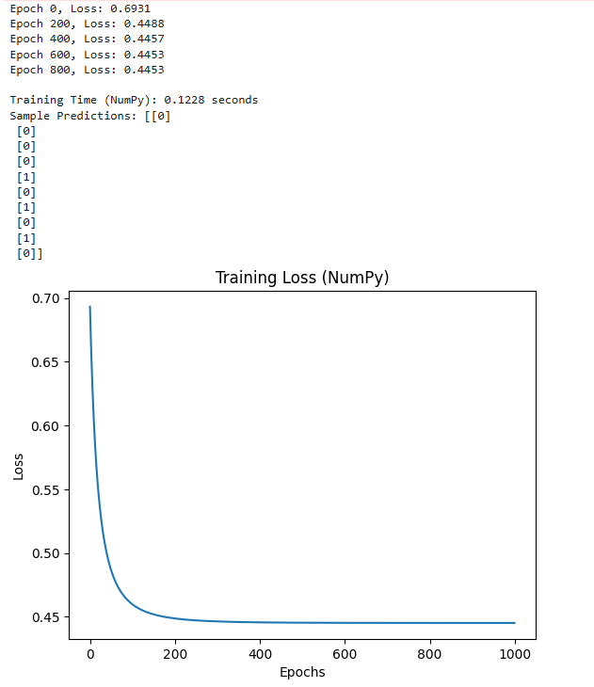

With Jax:
import pandas as pd
import numpy as np
import time

import jax.numpy as jnp
from jax import grad, jit, vmap

from sklearn.preprocessing import StandardScaler

# -------------------------
# Load data
# -------------------------
train_data = pd.read_csv("train.csv")
test_data = pd.read_csv("test.csv")

# -------------------------
# Preprocessing (FIXED warning)
# -------------------------
features = ['Pclass', 'Sex', 'Age', 'SibSp', 'Parch', 'Fare']

# Fix chained assignment issue
train_data['Age'] = train_data['Age'].fillna(train_data['Age'].mean())
test_data['Age'] = test_data['Age'].fillna(train_data['Age'].mean())

train_data['Sex'] = train_data['Sex'].map({'male': 0, 'female': 1})
test_data['Sex'] = test_data['Sex'].map({'male': 0, 'female': 1})

train_data = train_data.dropna(subset=features + ['Survived'])

# Extract features
X_train = train_data[features].values
y_train = train_data['Survived'].values.reshape(-1, 1)

X_test = test_data[features].fillna(0).values

# Scale
scaler = StandardScaler()
X_train = scaler.fit_transform(X_train)
X_test = scaler.transform(X_test)

# Convert to JAX arrays
X_train = jnp.array(X_train)
y_train = jnp.array(y_train)
X_test = jnp.array(X_test)

# -------------------------
# Model
# -------------------------
def sigmoid(z):
return 1 / (1 + jnp.exp(-z))

def predict(W, b, X):
return sigmoid(jnp.dot(X, W) + b)

# -------------------------
# Loss function
# -------------------------
def loss_fn(W, b, X, y):
y_pred = predict(W, b, X)
eps = 1e-7
return -jnp.mean(y * jnp.log(y_pred + eps) + (1 - y) * jnp.log(1 - y_pred + eps))

# -------------------------
# Gradients
# -------------------------
grad_fn = grad(loss_fn, argnums=(0, 1))

# -------------------------
# Vectorized prediction (vmap)
# -------------------------
batched_predict = vmap(lambda x, W, b: sigmoid(jnp.dot(x, W) + b), in_axes=(0, None, None))

# -------------------------
# JIT compile training step
# -------------------------
@jit
def update(W, b, X, y, lr):
dW, db = grad_fn(W, b, X, y)
W = W - lr * dW
b = b - lr * db
return W, b

# -------------------------
# Initialize
# -------------------------
W = jnp.zeros((X_train.shape[1], 1))
b = 0.0

lr = 0.1
epochs = 1000

# -------------------------
# Training
# -------------------------
start = time.time()
loss_history = []

for i in range(epochs):
W, b = update(W, b, X_train, y_train, lr)

current_loss = loss_fn(W, b, X_train, y_train)
loss_history.append(current_loss)

if i % 200 == 0:
print(f"Epoch {i}, Loss: {current_loss:.4f}")

end = time.time()

print("\nTraining Time (JAX):", round(end - start, 4), "seconds")

# -------------------------
# Predictions (fast batch using vmap)
# -------------------------
y_pred_test = batched_predict(X_test, W, b)
y_pred_labels = (y_pred_test > 0.5).astype(int)

print("Sample Predictions:", y_pred_labels[:10])

import matplotlib.pyplot as plt

plt.figure()
plt.plot(loss_history)
plt.title("Training Loss (JAX)")
plt.xlabel("Epochs")
plt.ylabel("Loss")
plt.show()

Explanation:
- Implements Logistic Regression using JAX, which supports automatic differentiation and just-in-time (JIT) compilation.
- Data preprocessing:
  - Loads the Titanic dataset.
  - Fills missing Age values.
  - Encodes Sex numerically.
  - Selects key features and standardizes them.
  - Converts data into JAX arrays for efficient computation.
- Model setup:
  - Uses a sigmoid function for predictions.
  - Computes binary cross-entropy loss to measure performance.
- JAX advantages:
  - grad automatically computes gradients of the loss w.r.t weights and bias.
  - jit compiles the update step into optimized machine code, speeding up training.
  - vmap vectorizes predictions across all samples for fast batch inference.
- Training process:
  - Updates weights and bias via gradient descent over multiple epochs.
  - Tracks and prints loss periodically.
- Post-training:
  - Makes predictions on the test set.
  - Converts probabilities into binary labels.
  - Plots the training loss curve.
- Key benefit: Replaces manual loops and derivatives with automatic differentiation and JIT compilation, enabling faster and more scalable training.

Output:
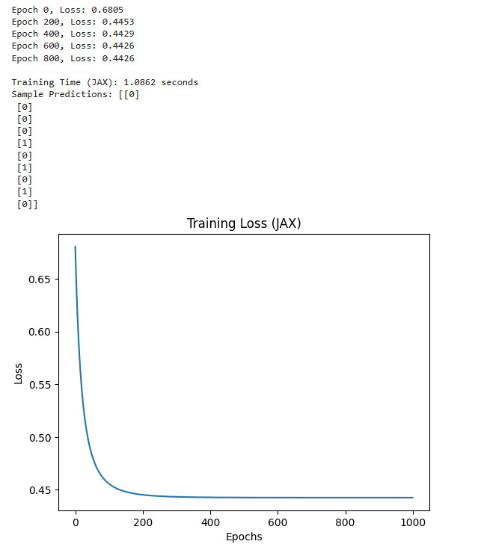

Commit History:
this is the commit history made by group members:
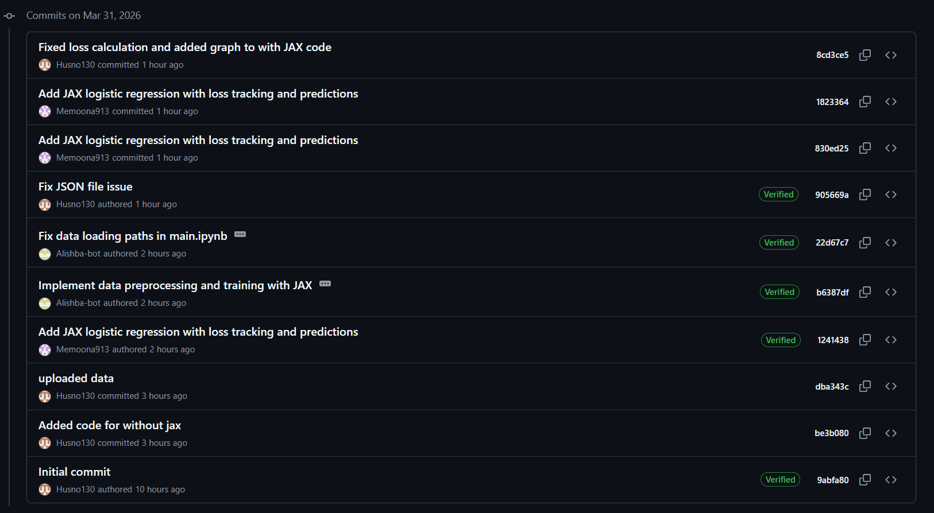
As in the above picture, we have divided the tasks among the group members and everything did theirs and committed their work on GitHub. We have done this task locally on vs code and connected it with git.

Analysis:
Both implementations successfully train a Logistic Regression model to predict survival, showing that the model learns effectively as the loss decreases over time. The NumPy version demonstrates the full step-by-step process, including manual gradient calculations, making it easier to understand how the algorithm works internally. In contrast, the JAX version produces similar prediction results but achieves faster training due to automatic differentiation and optimized computation through JIT compilation. Overall, while both approaches are correct and yield comparable outputs, the JAX implementation is more efficient and scalable, whereas the NumPy version is more suitable for learning and understanding the core concepts.
Even though Jax should run faster, in this case the NumPy code runs faster. This is because there are several different overheads involved that increase the time. The compilation of the Jax code takes time and since the python loop isn’t part of the complied Jax code, it has its own overheads that add to the time. At such small scales it is more practical and more efficient to use simple NumPy code instead of Jax code due to its increase of time due to its overheads

Environment:
- Vscode
- Ipynb notebook
- Virtual environment
- GitHub repo
- Core I5 8th gen

Reflection Questions

1. Why is vmap more efficient than looping over individual samples?
While a Python loop (e.g., for x in dataset) is easy to write, it is the "bottleneck" of data science for two main reasons:
- The Python Interpreter Overhead: Every time a loop iterates in Python, the interpreter must perform "type checking" and "dispatching" for the operation. If you have 891 rows in the Titanic dataset, Python explains to the CPU 891 times how to do a dot product. vmap (vectorized map) eliminates this by translating the operation into a single instruction for a batch of data.
- Memory Locality and SIMD: vmap allows the hardware to use SIMD (Single Instruction, Multiple Data). Instead of fetching one row of passenger data from RAM, processing it, and going back for the next, vmap fetches a contiguous block of memory.
- Hardware Utilization: On a GPU, a loop is sequential (one after another). vmap transforms the task so that each passenger's survival probability is calculated on a different GPU core simultaneously.

2. How does combining jit with grad improve training speed and accuracy?
This combination is often called "Compile-time Optimization." Here is how they work together:

For Speed: XLA Compilation
When you use grad, JAX builds a "trace" (a mathematical map) of your function. On its own, this trace is still executed step-by-step.
- Operator Fusion: When you wrap grad in jit, the XLA (Accelerated Linear Algebra) compiler looks at the entire gradient calculation. It "fuses" operations. For example, instead of calculating $e^{-x}$, then adding $1$, then dividing (which requires three separate memory writes), JIT creates one single custom kernel that does it all in one pass. This drastically reduces the time the CPU/GPU spends waiting for data to move.

For Accuracy: Automatic Differentiation vs. Numerical Estimates
- Analytical Precision: grad does not "estimate" the slope by checking two points (numerical differentiation). It uses Automatic Differentiation (AD). It breaks your Titanic model into fundamental primitives (addition, multiplication, logs) and applies the Chain Rule to machine precision.
- No Truncation Errors: Because it uses the exact symbolic derivative logic, you don't suffer from the "step-size" errors ($\epsilon$) found in traditional calculus approximations. This means your model weights are updated using the most mathematically perfect direction possible, leading to more stable convergence.

